Step 1: Understanding the SIH Problem Statement
What is the Government actually asking?
The title says:
Early detection and management of crop diseases and pest infestations.
Notice the wording.
It is not asking for only disease detection.
It is asking for an end-to-end crop health ecosystem.
The system must help from:
Detection → Forecasting → Validation → Management → Monitoring → Government Surveillance
That's the complete lifecycle.

Step 2: Breaking the Problem Statement into Requirements
Let's decode every sentence.

Problem 1: Late Detection
Farmers recognize diseases only after visible damage spreads.
Meaning:
The system must identify problems as early as possible.
Required capability
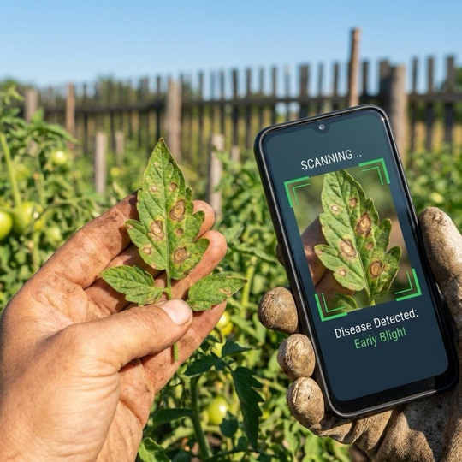
- Leaf image detection
- Pest image detection
- Early symptom recognition
- Confidence score
This maps directly to AgriOS's Crop Health Engine.

Problem 2: Experts Cannot Reach Every Farm
Extension staff cover large areas.
Meaning:
Human experts are limited.
The software must reduce unnecessary field visits.
Required capability
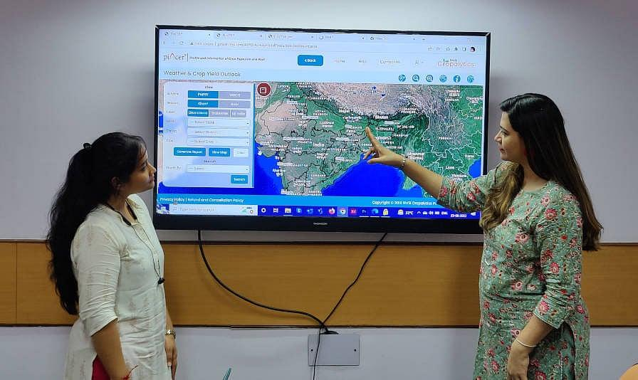
Instead of sending experts everywhere,
the system should:
- Prioritize high-risk farms.
- Escalate uncertain cases.
- Share reports digitally.
This introduces a completely new stakeholder:
Extension Officer Dashboard
AgriOS currently focuses on farmers.
SIH requires both.

Problem 3: Laboratory Diagnosis Takes Time
Meaning:
The app should provide an initial assessment before laboratory confirmation.
Important wording:
"Expert validation"
Notice they never say AI replaces experts.
Instead,
AI becomes the first screening layer.
Workflow:
Farmer → AI → Expert → Laboratory (if needed)

Problem 4: Multiple Factors Affect Disease Risk
The statement lists:
- Weather
- Crop stage
- Crop variety
- Soil condition
- Local pest history
These are critical.
Instead of detecting disease only after it appears,
the system should predict risk.
Example:
"Cotton in Nashik has 82% risk of Pink Bollworm next week."
This becomes a forecasting module.

Problem 5: Incorrect Diagnosis Causes Problems
The statement mentions:
- Wrong pesticides
- Excessive spraying
- Higher cost
- Residue concerns
Therefore,
the solution cannot simply say:
"Spray pesticide."
It must recommend:
- Integrated Pest Management (IPM)
- Safe dosage
- Organic alternatives
- Protective precautions
This is much more aligned with government agricultural practices.

Step 3: Expected Solution (Decoded)
The expected solution paragraph is actually a feature checklist.
Let's convert it.
|
Government Requirement
|
Meaning
|
| --- | --- |
|
Image-based identification
|
AI image detection
|
|
Pest trap inputs
|
Trap monitoring
|
|
Sensor inputs
|
Environmental sensing
|
|
Weather forecasting
|
Risk prediction
|
|
Geospatial hotspot mapping
|
Disease map
|
|
Expert validation
|
Extension officer workflow
|
|
Multilingual advisories
|
Local language
|
|
IPM recommendations
|
Safe treatment
|
|
Referral system
|
Lab/Officer escalation
|
|
Follow-up monitoring
|
Recovery tracking
|
|
Dashboards
|
Government analytics
|
This is your blueprint.

Step 4: Similarity with AgriOS
Now let's compare honestly.
|
SIH Requirement
|
AgriOS
|
| --- | --- |
|
Image detection
|
✅ Already exists
|
|
Weather integration
|
✅ Exists
|
|
Multilingual
|
✅ Exists
|
|
Recommendations
|
✅ Exists
|
|
AI explanation
|
✅ Exists
|
|
Farmer dashboard
|
✅ Exists
|
|
Pest trap
|
❌ Missing
|
|
Expert validation
|
❌ Missing
|
|
Government dashboard
|
❌ Missing
|
|
Hotspot mapping
|
Partial
|
|
Field confirmation learning
|
❌ Missing
|
|
Extension workflow
|
❌ Missing
|
So instead of building everything,
you should build around these missing government-focused features.

Step 5: Proposed SIH Solution
Instead of calling it AgriOS,
think of this as a new system.
Working Concept
Crop Health Intelligence Platform
Its mission:
Detect early. Predict outbreaks. Guide treatment. Support officials.
Step 6: System Architecture (SIH Version)
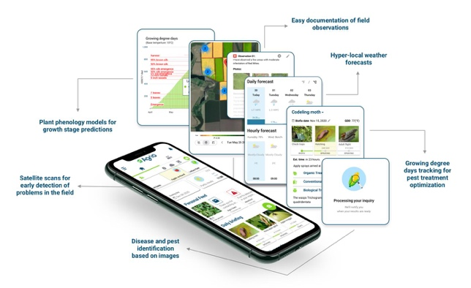
The architecture becomes much simpler than AgriOS.
|
Layer
|
Purpose
|
| --- | --- |
|
Farmer App
|
Capture images
|
|
AI Detection
|
Identify disease
|
|
Risk Engine
|
Forecast outbreaks
|
|
Decision Engine
|
Recommend actions
|
|
Expert Portal
|
Validate cases
|
|
Government Dashboard
|
Monitor hotspots
|
Notice:
No rover.
No Digital Twin.
No Market Engine.
Those are unnecessary for this problem.

Step 7: The Six Core Modules
These six modules almost perfectly mirror the SIH statement.

Module 1 — Image Diagnosis Engine
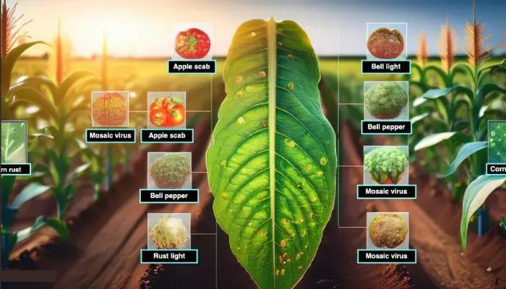
Purpose:
Identify diseases and pests from photos.
Input:
- Leaf image
- Crop type
- Growth stage
Output:
- Disease
- Confidence
- Severity
- Similar cases
Possible models:
- MobileNetV3
- EfficientNet-B0
- YOLOv8 (for pest detection)
This is your strongest existing expertise.

Module 2 — Pest Surveillance Module
This is something AgriOS does not have.
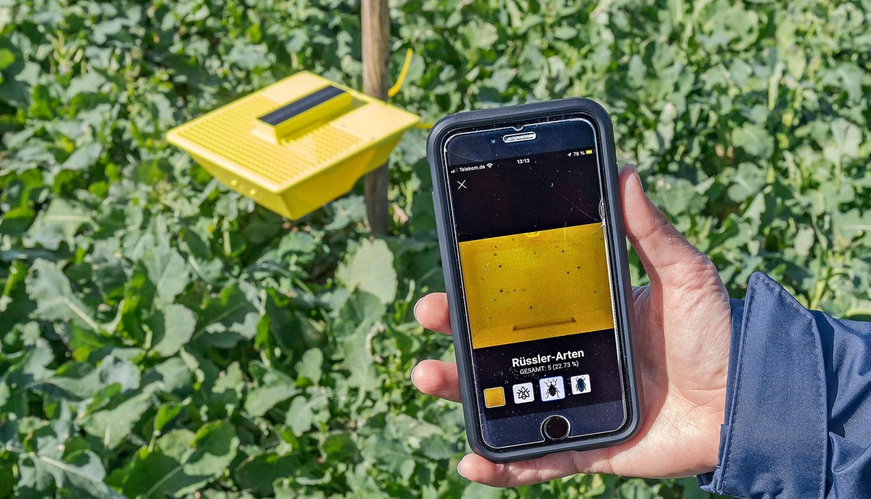
Purpose:
Monitor insect populations.
Input:
- Sticky trap image
- Light trap counts
- Manual counts
Output:
- Pest count
- Infestation level
- Trend
This directly satisfies
"pest-trap inputs."

Module 3 — Weather Risk Forecasting
This is where prevention happens.
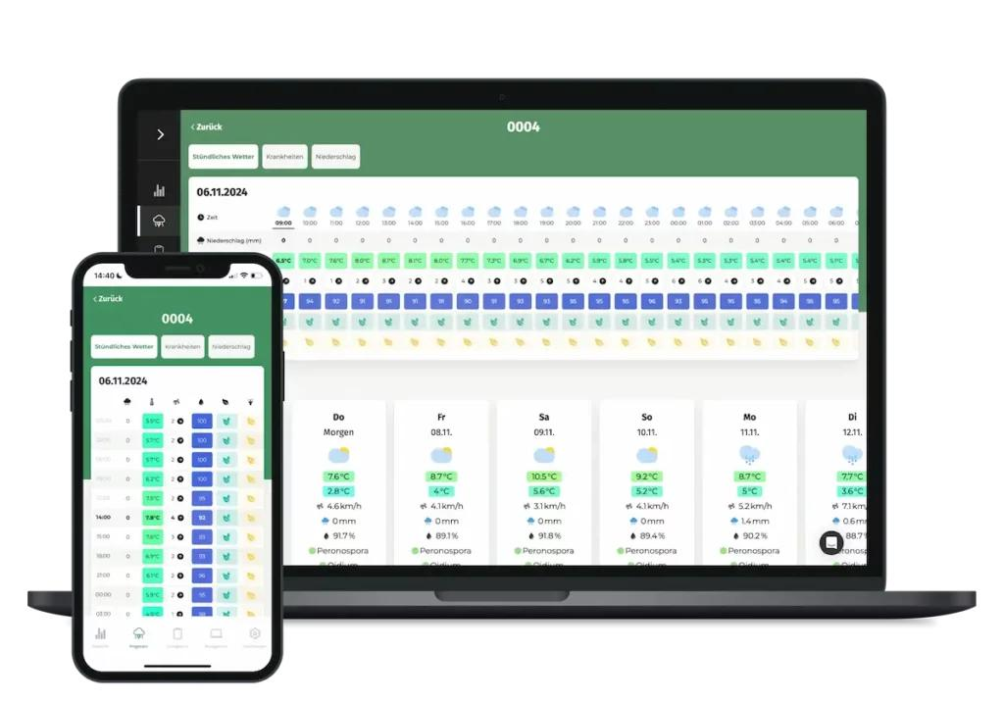
Inputs:
- Rainfall
- Temperature
- Humidity
- Crop stage
- Soil condition
Output:
- Risk percentage
- Expected outbreak window
- Preventive advice
Example:
Downy Mildew Risk: 78%
Expected in 3–5 days.

Module 4 — Geospatial Hotspot Mapping
This is one of the biggest SIH keywords.
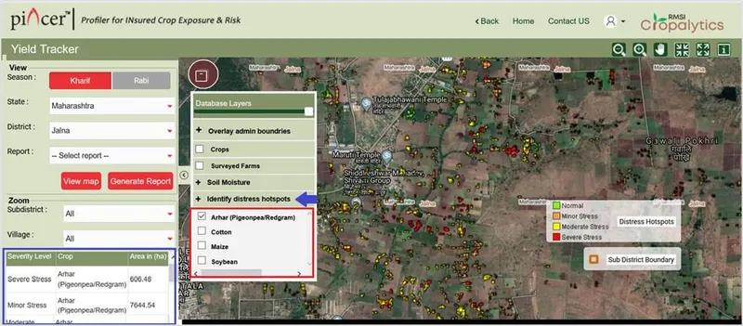
Every confirmed case gets GPS coordinates.
The system generates:
- Heatmaps
- Village clusters
- District summaries
Officials immediately know where outbreaks are growing.
This is much more valuable than individual predictions.

Module 5 — Expert Validation Workflow
This is the government workflow.
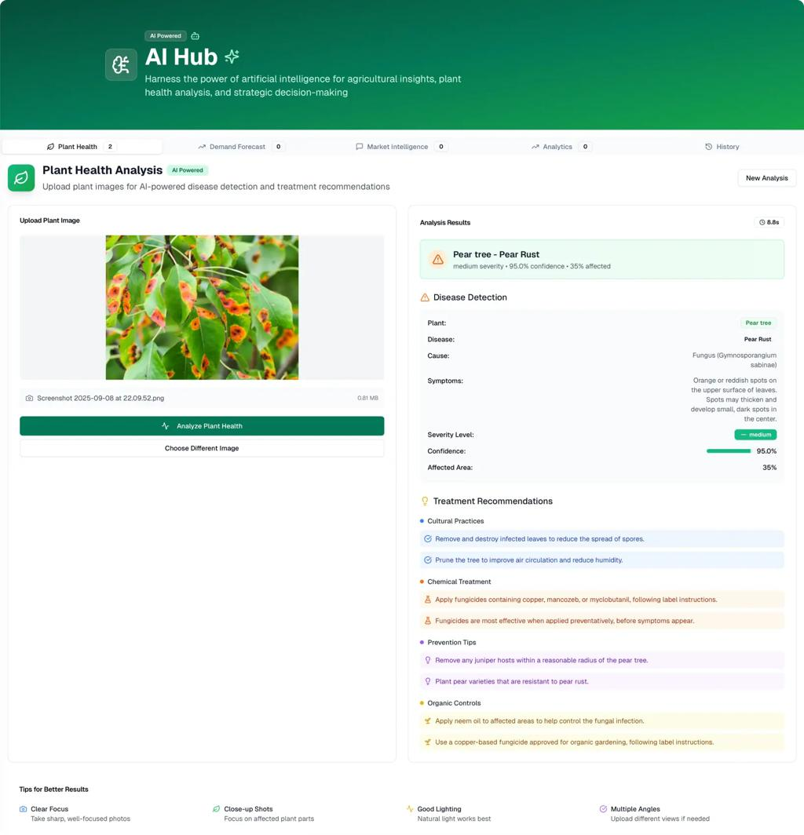
Instead of:
AI → Farmer
The workflow becomes:
AI detects
↓
Extension officer reviews
↓
Approves or edits
↓
Farmer receives validated advice.
This satisfies
"expert validation."

Module 6 — Learning Feedback System
This sentence appears at the end.
"The system should learn from field confirmations."
This is extremely important.
Workflow:
Prediction
↓
Farmer applies treatment
↓
Follow-up image
↓
Expert confirms
↓
Model learns
This becomes continuous improvement.

Step 8: User Roles
Unlike AgriOS,
SIH requires multiple users.
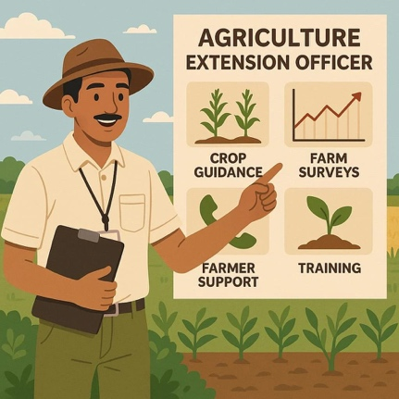
Farmer
Can:
- Capture images
- Receive alerts
- View treatments
- Track recovery
Extension Officer
Can:
- Validate cases
- Prioritize visits
- Refer to labs
- Approve advisories
Agriculture Official
Can:
- View hotspot maps
- Monitor outbreaks
- Generate reports
- Plan interventions
This role separation closely follows the PS.

Step 9: AI Pipeline
The complete AI pipeline becomes:
|
Stage
|
Function
|
| --- | --- |
|
Image
|
Disease detection
|
|
Pest Trap
|
Pest counting
|
|
Weather
|
Risk forecasting
|
|
GPS
|
Location tagging
|
|
Decision
|
Treatment recommendation
|
|
Expert
|
Validation
|
|
Dashboard
|
Government monitoring
|
Every stage corresponds to a sentence from the PS.

Step 10: Recommended Technology Stack
Keep it realistic for SIH.
|
Layer
|
Technology
|
| --- | --- |
|
Frontend
|
React
|
|
Mobile
|
React Native (optional)
|
|
Backend
|
FastAPI
|
|
Database
|
PostgreSQL + PostGIS
|
|
AI
|
PyTorch
|
|
Disease Model
|
EfficientNet
|
|
Pest Detection
|
YOLOv8
|
|
Maps
|
Leaflet
|
|
Weather
|
IMD/OpenWeather
|
|
Storage
|
Cloudinary
|
|
Authentication
|
JWT
|
This stack is achievable in 3–4 months.

Step 11: Development Roadmap
Phase 1 — Foundation (Week 1–2)
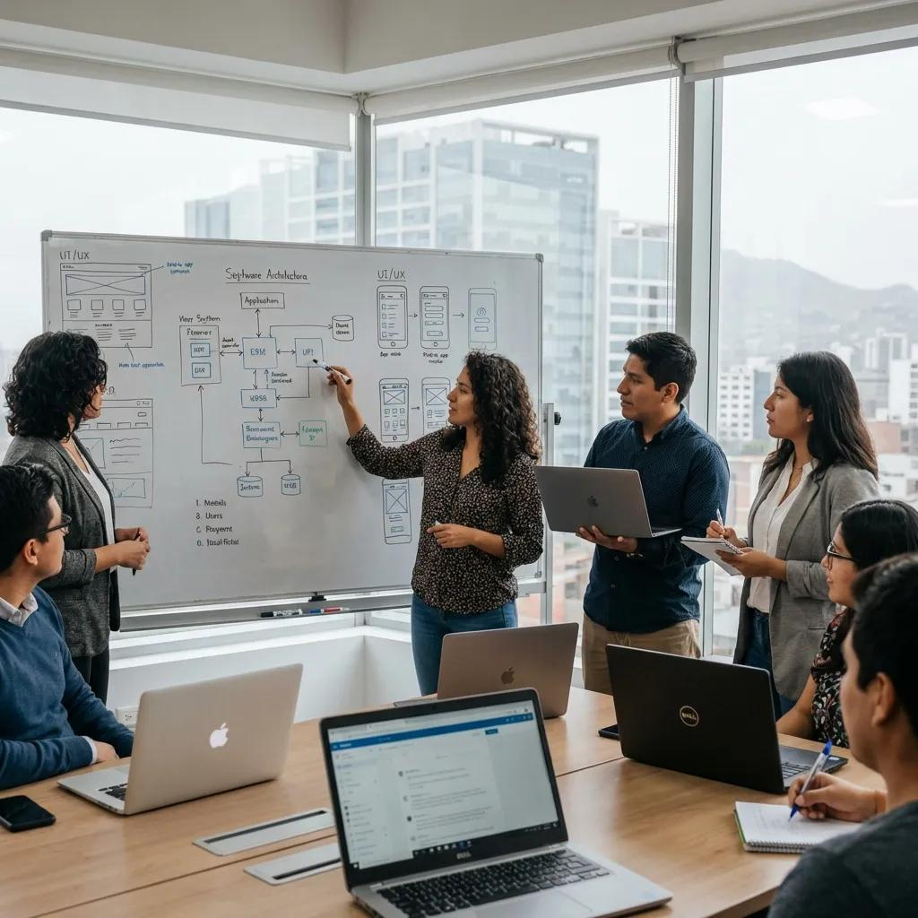
Build:
- Authentication
- Farmer profile
- Crop registration
- Backend setup
Deliverable:
Working login.

Phase 2 — AI Diagnosis (Week 3–5)
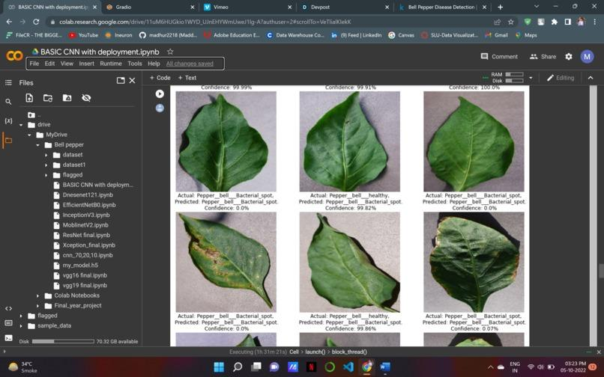
Build:
- Image upload
- Disease prediction
- Confidence score
- Severity estimation
Deliverable:
First working AI.

Phase 3 — Forecasting (Week 6–7)
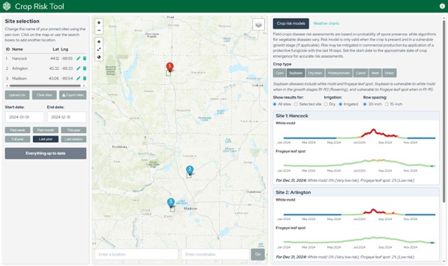
Integrate:
- Weather
- Risk calculation
- Preventive alerts
Deliverable:
Disease forecasting.

Phase 4 — Pest Module (Week 8–9)
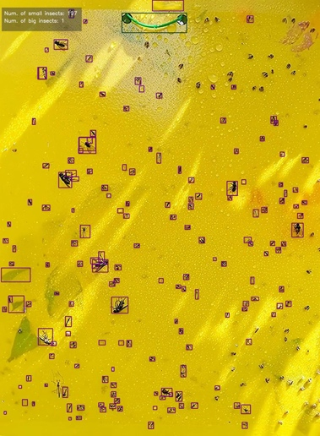
Build:
- Trap image upload
- Pest counting
- Infestation level
Deliverable:
Pest monitoring.

Phase 5 — Government Features (Week 10–11)
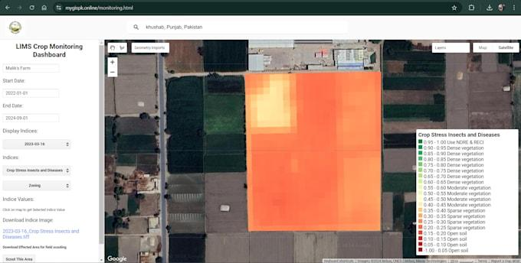
Build:
- Hotspot map
- Expert portal
- Validation workflow
Deliverable:
Official dashboard.

Phase 6 — Final Integration (Week 12)
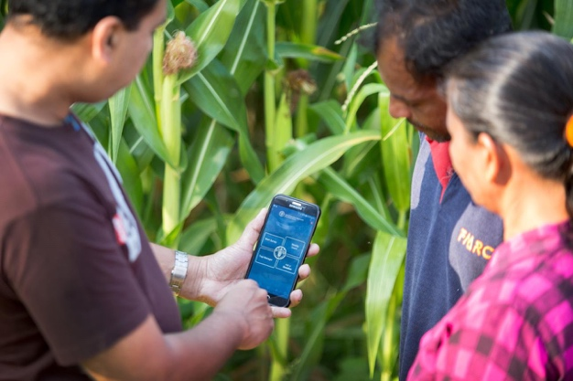
Add:
- Multilingual
- Notifications
- Follow-up monitoring
- Final testing
Deliverable:
SIH-ready prototype.

Step 12: Why this aligns strongly with PS 26131
|
PS Requirement
|
Proposed Feature
|
| --- | --- |
|
Image-based symptom identification
|
Disease Detection Engine
|
|
Pest-trap inputs
|
Pest Surveillance Module
|
|
Sensor inputs
|
Weather + Manual Inputs
|
|
Weather forecasting
|
Risk Forecast Engine
|
|
Geospatial hotspot mapping
|
GIS Heatmap
|
|
Expert validation
|
Extension Portal
|
|
Multilingual advisories
|
Farmer App
|
|
Integrated Pest Management
|
Recommendation Engine
|
|
Referral to laboratories
|
Escalation Workflow
|
|
Follow-up monitoring
|
Recovery Tracker
|
|
Learning from confirmations
|
Feedback System
|
|
Dashboards
|
Government Analytics
|

Strategic recommendation for SIH
If I were positioning this for SIH 2026, I would avoid mentioning AgriOS in the presentation. Instead, I'd present this as a solution designed directly from the Government of Maharashtra's workflow, because the evaluators will likely compare your prototype against the exact phrases in the problem statement.
One advantage your team already has is that your AgriOS work gives you a head start on several difficult components FastAPI architecture, multilingual AI interaction, disease detection models, and explainable recommendations. The effort should now focus on adding the government-facing capabilities that the PS emphasizes: expert validation, hotspot surveillance, pest-trap monitoring, and field-confirmation learning. Those four features are what will make the solution feel like it was built specifically for PS 26131, rather than adapted from another project.

The problem statement says "image-based symptom identification, pest-trap or sensor inputs". The key word is "or", which means hardware is optional, not mandatory. You can build a highly competitive software solution using a smartphone, weather APIs, and image AI, and then support optional sensor integration.

My recommendation for SIH 2026
Build the core solution without hardware first. Then add a small optional hardware extension if time permits. This aligns with the Software category of the problem statement and keeps the project achievable.
What the problem statement actually requires
|
Feature
|
Hardware Needed?
|
| --- | --- |
|
Leaf image disease detection
|
❌ No (phone camera)
|
|
Pest image detection
|
❌ No
|
|
Weather-based forecasting
|
❌ No (API)
|
|
Geospatial hotspot mapping
|
❌ No (phone GPS)
|
|
Expert validation
|
❌ No
|
|
Multilingual advisories
|
❌ No
|
|
Pest-trap monitoring
|
⚠️ Optional
|
|
Sensor inputs
|
⚠️ Optional
|
So around 80–90% of the solution can be built without any IoT hardware.
Version 1 (Recommended SIH Prototype)
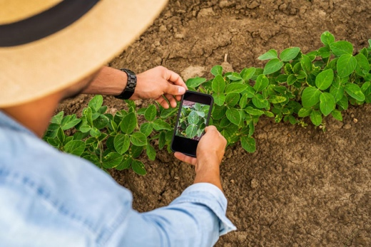
The farmer only needs a smartphone.
Workflow:
- Open the app.
- Select crop.
- Take a photo.
- GPS is captured automatically.
- Weather is fetched from an API.
- AI predicts disease.
- Risk forecast is generated.
- Advisory is shown.
This already satisfies most of the expected outcomes.
Optional Hardware Add-ons (Bonus Points)
If the judges ask, "How can this scale further?", you can demonstrate these as future-ready integrations.
Option 1 – Smart Pest Trap (Most Valuable)
This is the one hardware I'd prioritize.
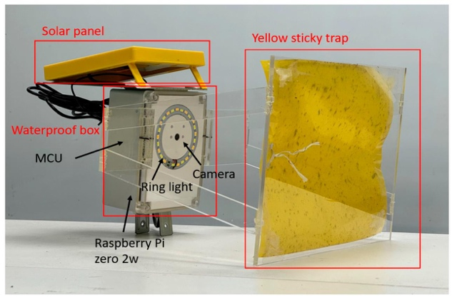
Components
- ESP32-CAM
- Yellow sticky trap
- Solar/battery (optional)
How it works:
- Camera captures trap images.
- AI counts insects.
- Infestation trend is updated automatically.
Why it's good:
- Directly matches "pest-trap inputs."
- Low-cost.
- Easy demo.

Option 2 – Weather & Environment Node
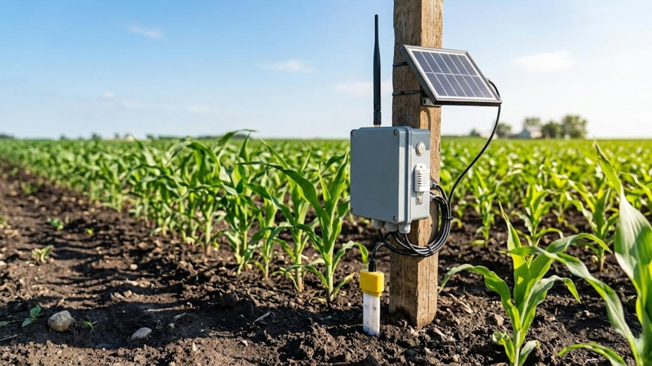
Components
- ESP32
- DHT22
- Soil moisture sensor
Purpose:
Instead of relying only on weather APIs,
the system gets actual field conditions.
Useful for improving disease-risk accuracy.

Option 3 – Light Trap Counter
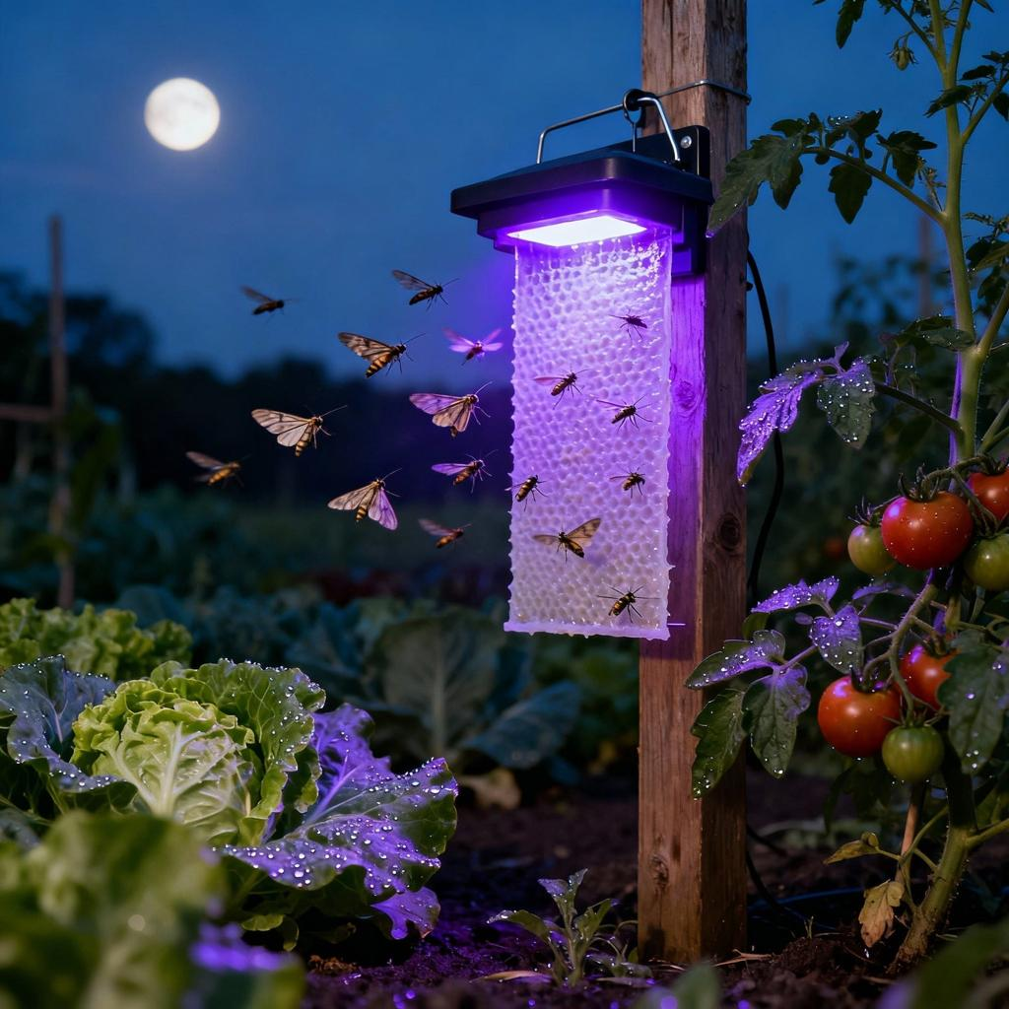
A camera periodically counts insects attracted to the light.
This helps monitor:
- Moths
- Flying pests
- Population growth
Recommended Hardware Roadmap
|
Priority
|
Feature
|
| --- | --- |
⭐⭐⭐⭐⭐
|
Smartphone-only AI system
|
⭐⭐⭐⭐
|
ESP32-CAM Smart Pest Trap
|
⭐⭐⭐
|
Weather/Soil Sensor Node
|
⭐⭐
|
Automated Light Trap
|
⭐
|
Drone integration (future)
|
If I were building this for SIH
I'd pitch it like this:
"Our solution is designed as a software-first platform, ensuring immediate adoption by farmers using only a smartphone. However, the architecture is extensible and supports optional IoT devices such as ESP32-based smart pest traps and environmental sensor nodes for automated field surveillance."
That statement is powerful because it stays true to the Software category while showing future scalability.
One idea that could impress SIH judges (without much extra work)
Instead of putting expensive sensors across the field, build one AI-enabled Smart Pest Trap using an ESP32-CAM (₹700–900) and a yellow sticky card. The farmer can simply place it in the field, and every few hours it captures an image, counts insects using a YOLO model, and sends the count to the app. Combined with smartphone disease detection and weather forecasting, this covers almost every technical expectation in PS 26131 while keeping the hardware minimal and affordable.

The system follows this idea:
Capture → Analyze → Forecast → Validate → Advise → Monitor → Survey
SIH 2026 PS 26131 – Complete System Flow
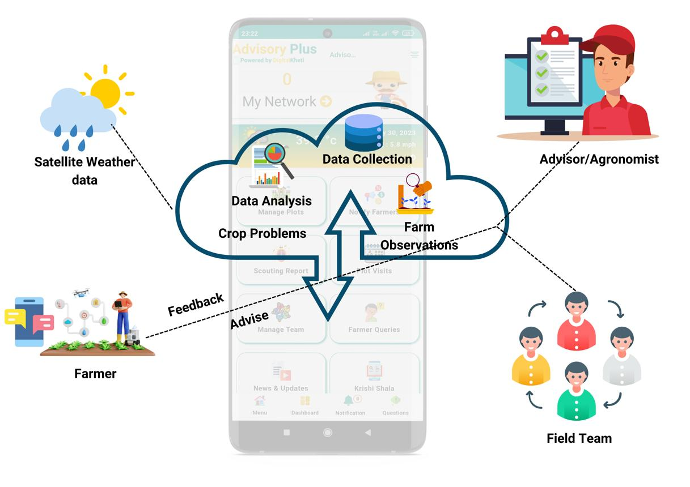
Step-by-step workflow
- 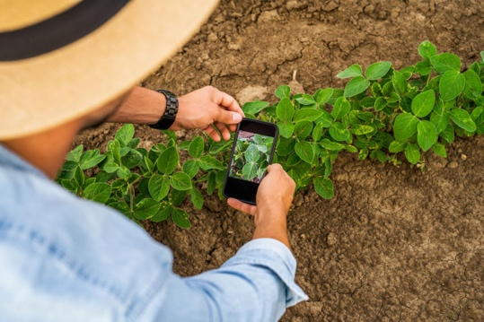
Farmer captures field data
The farmer opens the app and selects the crop, growth stage, and farm location. They upload a leaf image, pest image, or pest-trap image, while GPS is captured automatically.
AI performs early detection
The AI analyzes the uploaded image to identify diseases or pests, estimate severity, and generate a confidence score.
Risk Forecast Engine predicts outbreaks
The system combines weather API data (temperature, humidity, rainfall forecast), crop stage, crop variety, and location to predict the likelihood of disease or pest outbreaks before major damage occurs.
- 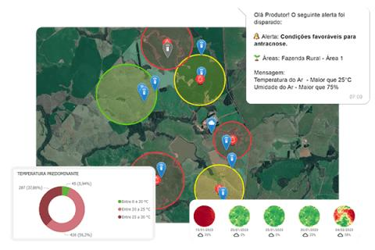
Location is added to surveillance
Every reported case is tagged with GPS coordinates and contributes to village, taluk, and district-level hotspot maps.
- 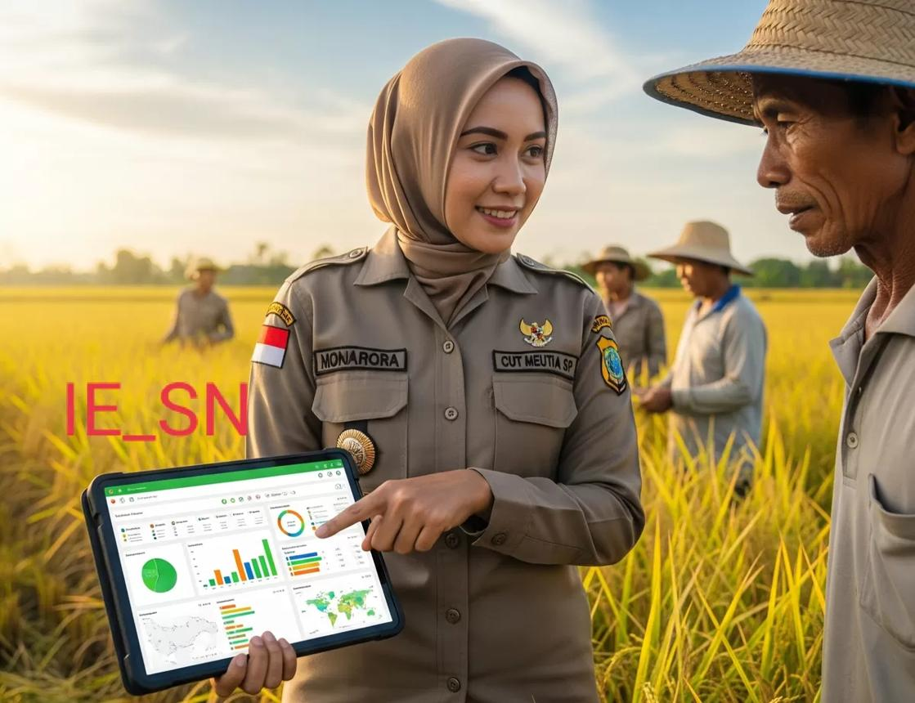
Extension officer validates cases
High-risk or low-confidence cases appear in the Extension Officer Dashboard, where officers can review images, approve or correct the diagnosis, and refer cases to laboratories if needed.
- 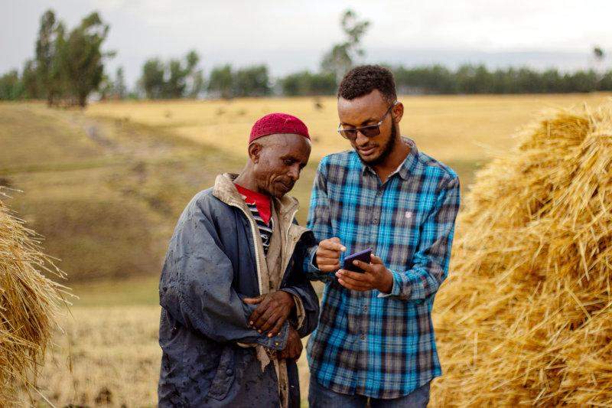
Farmer receives multilingual advisory
After AI prediction or expert validation, the farmer receives Integrated Pest and Disease Management recommendations, safe pesticide usage, dosage guidance, organic alternatives, preventive measures, and next-step instructions in their preferred language.
- 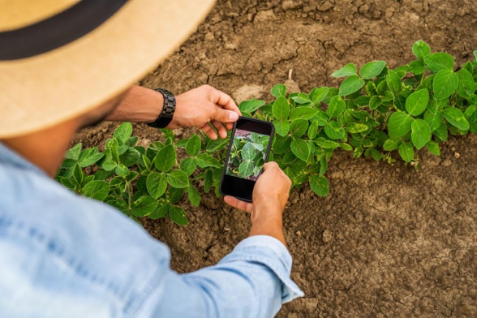
Follow-up monitoring
The farmer uploads follow-up images after treatment, and the system tracks recovery while updating the case status.
- 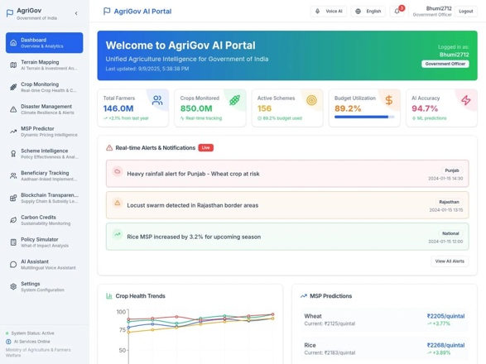
Government surveillance and planning
Agriculture officials view district-wide dashboards showing outbreak hotspots, disease trends, pest trends, validation statistics, and high-risk areas, helping them prioritize field visits and preventive interventions.
Role-wise interaction
|
Role
|
Responsibilities
|
| --- | --- |
|
Farmer
|
Capture images, receive alerts, follow advisories, upload follow-up images
|
|
Extension Officer
|
Validate AI predictions, approve advisories, refer cases to labs, prioritize field visits
|
|
Agriculture Official
|
Monitor hotspot maps, analyze district trends, plan interventions, generate reports
|
Simple Feature Mapping
|
Stage
|
Feature
|
| --- | --- |
|
Capture
|
Image Upload + GPS
|
|
Analyze
|
Disease & Pest Detection AI
|
|
Forecast
|
Weather-based Risk Prediction
|
|
Map
|
Geospatial Hotspots
|
|
Validate
|
Extension Officer Review
|
|
Advise
|
Multilingual IPM Recommendations
|
|
Monitor
|
Follow-up Tracking
|
|
Govern
|
Official Dashboard & Surveillance
|
One-line elevator pitch
Farmers capture crop images, AI detects and predicts disease risk using weather and location data, experts validate critical cases, multilingual treatment advice is delivered to farmers, and government dashboards monitor outbreak hotspots for faster intervention.
This flow is almost a 1:1 interpretation of SIH PS 26131, with every expected feature (image diagnosis, pest-trap support, weather forecasting, hotspot mapping, expert validation, multilingual advisories, follow-up monitoring, and government dashboards) integrated into a single logical pipeline without adding unnecessary AgriOS-specific modules like the rover or market engine.

Don't choose 4–5 taluks first. Choose 3–4 major crops, then select 4–5 taluks where those crops are actually important. That makes the heatmaps, forecasts, and advisories scientifically believable.
My recommended SIH strategy
Scope
- State for prototype: Tamil Nadu (easier for your team to validate locally)
- Taluks: 4–5
- Crops: 3–4
- Diseases: 8–12 total
- Pests: 5–8 total
Then, in the presentation, say:
"The architecture is crop-agnostic and can be extended to other districts and states."
That sounds much stronger than claiming nationwide coverage.
Step 1: Choose the Taluks
Instead of random taluks, pick places with different agricultural conditions.
- 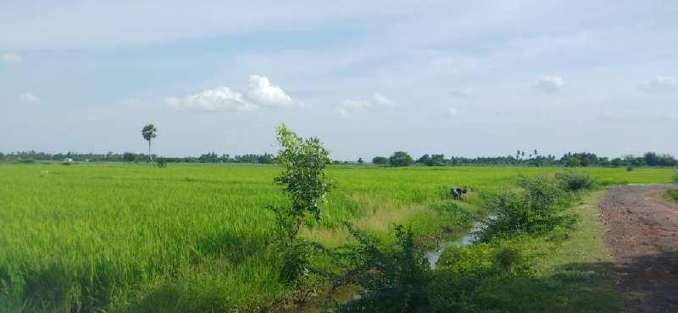
Kancheepuram — Paddy
- 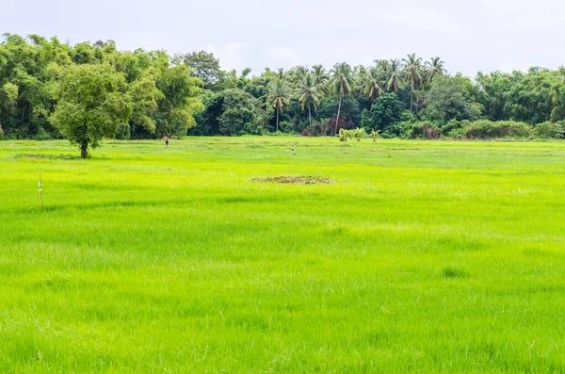
Thiruvallur — Paddy + Groundnut
- 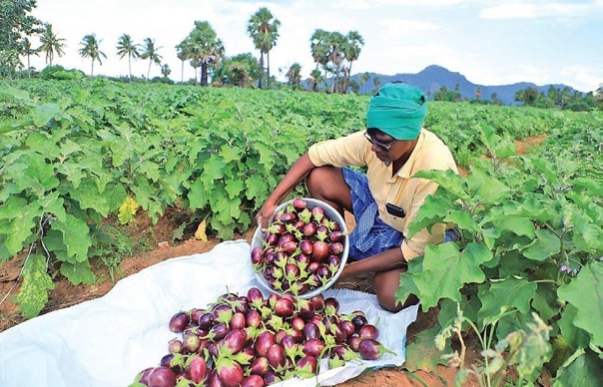
Vellore — Tomato
- 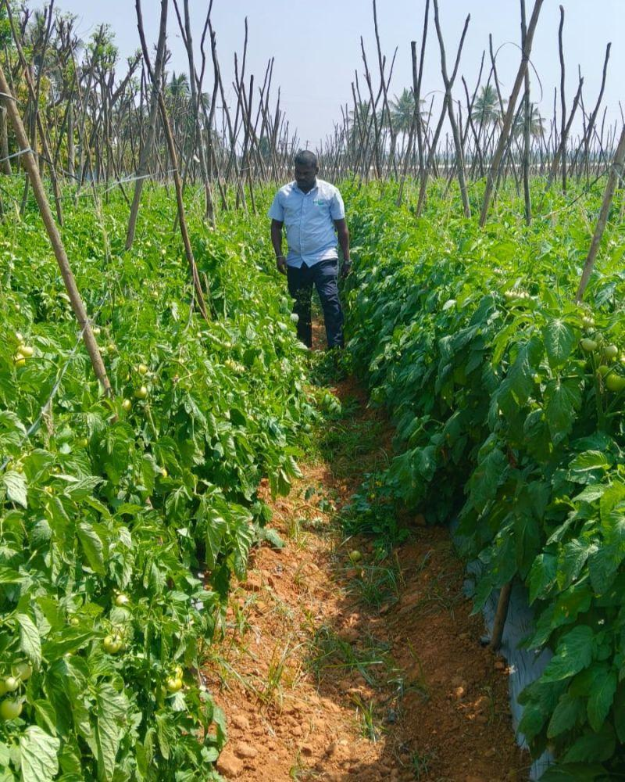
Krishnagiri — Tomato
- 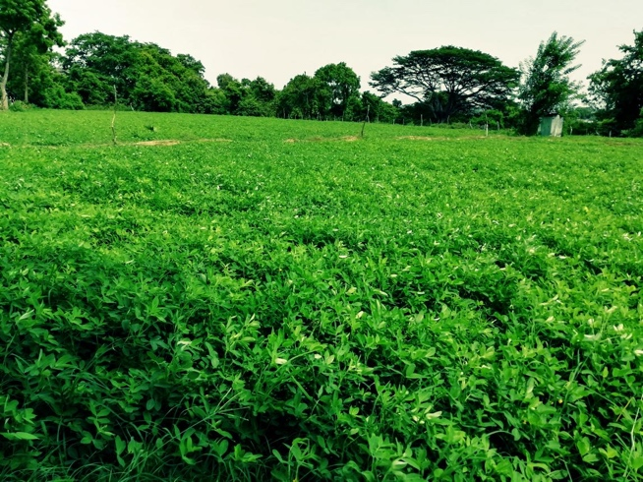
Villupuram — Groundnut
These aren't arbitrary—they represent crops that are actually cultivated there.
Why this helps
When your dashboard shows:
"Early Blight cases increasing in Krishnagiri"
it feels realistic.
Step 2: Choose the Crops
Don't exceed four.
These four give excellent datasets and cover different disease types.
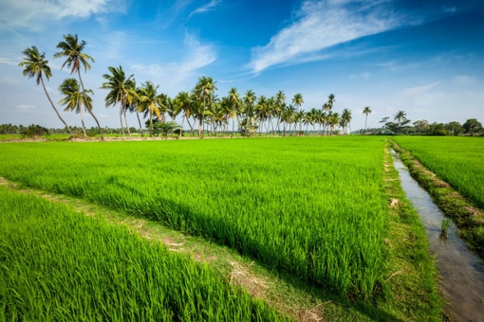
Paddy (Rice)
Major crop in Tamil Nadu with well-documented diseases and pests.
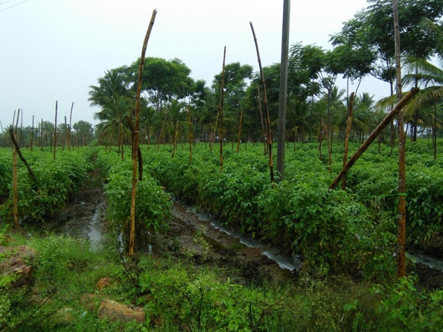
Tomato
Excellent public datasets for diseases.
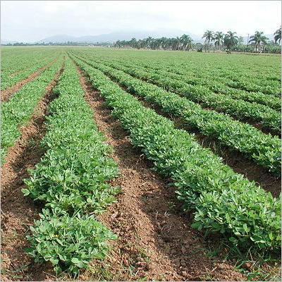
Groundnut
Important oilseed crop with both disease and pest problems.
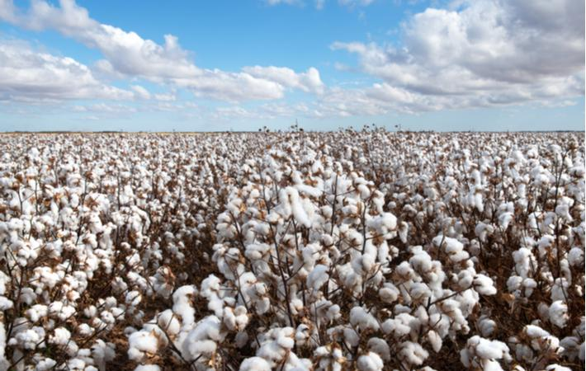
Cotton
Excellent for pest forecasting demonstrations.
These four together give a balanced prototype.
Step 3: Select Diseases
Keep them practical.
Paddy
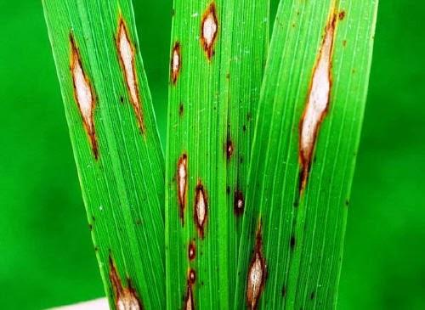
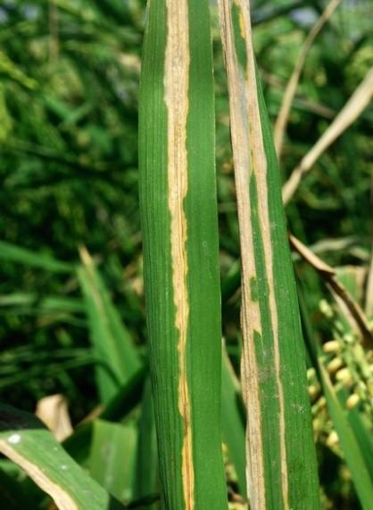
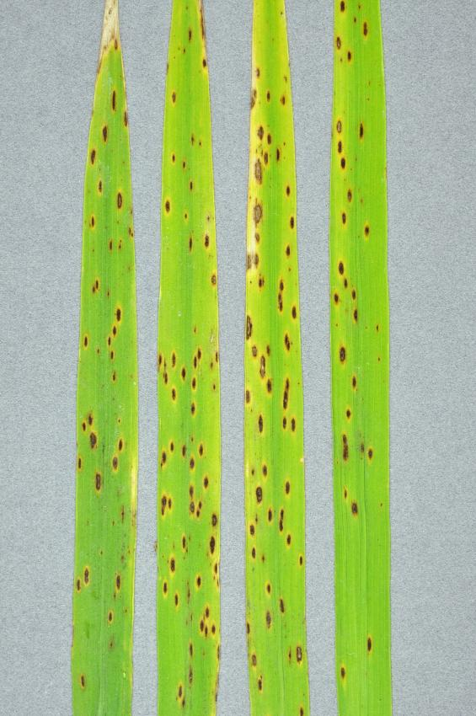
7
- Rice Blast
- Bacterial Leaf Blight
- Brown Spot
Tomato
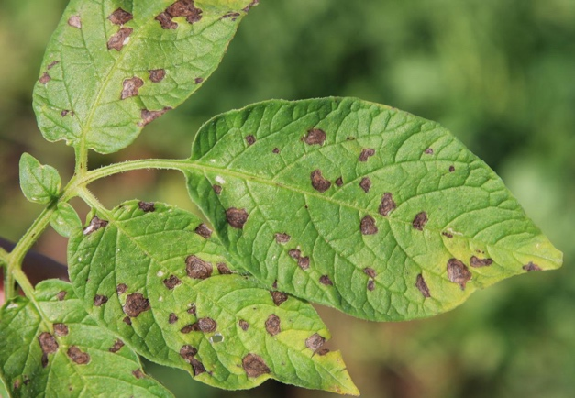
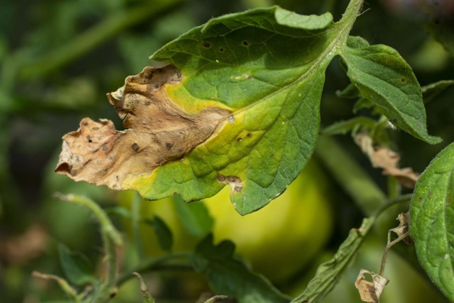
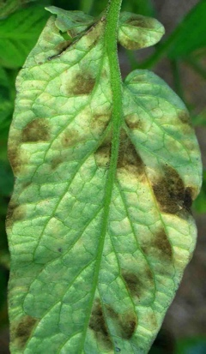
6
- Early Blight
- Late Blight
- Leaf Mold
Groundnut
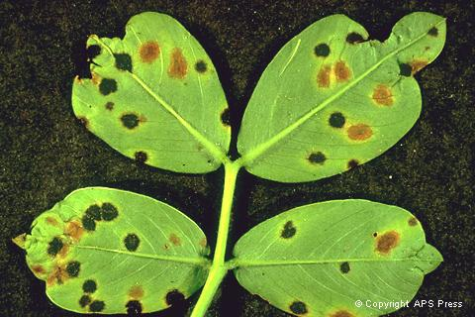
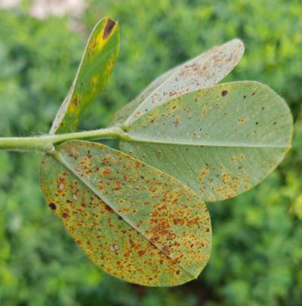
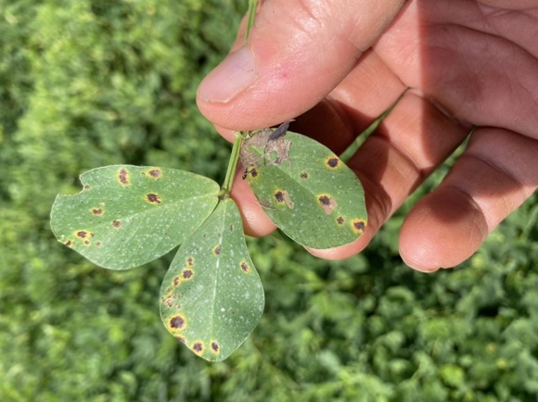
7
- Leaf Spot
- Rust
Cotton
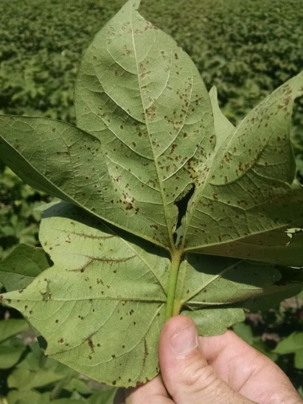
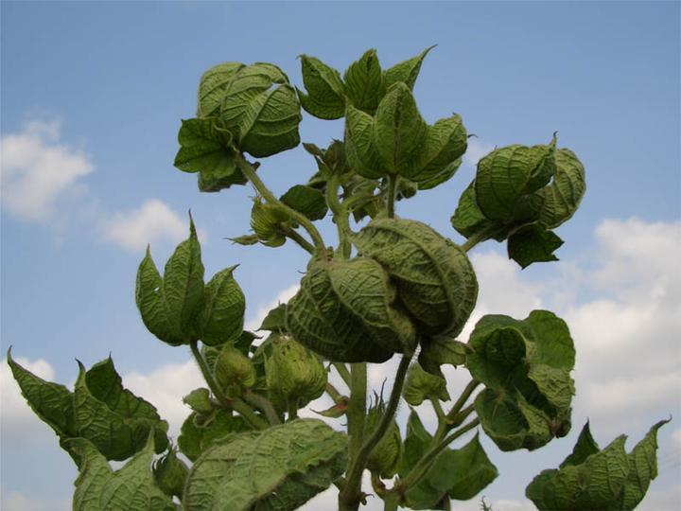
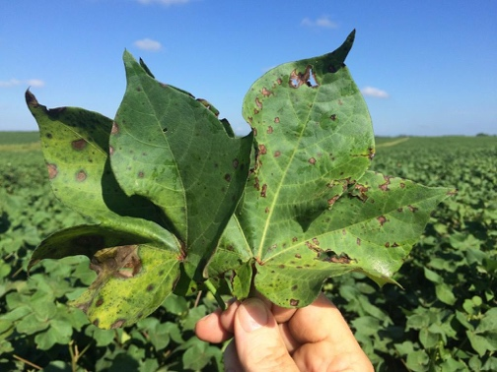
6
- Bacterial Blight
- Leaf Curl
Total:
10 diseases
This is enough for a convincing prototype.
Step 4: Select Pests
These are perfect because they're economically important.
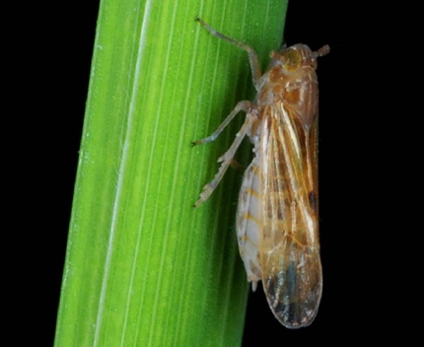
Brown Planthopper
Rice
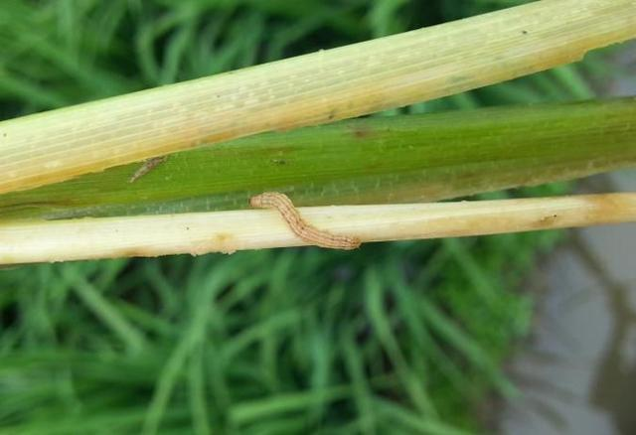
Stem Borer
Rice
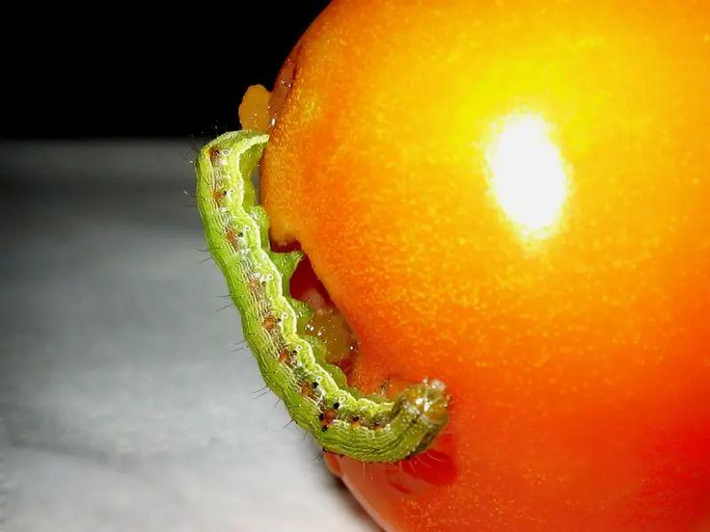
Fruit Borer
Tomato
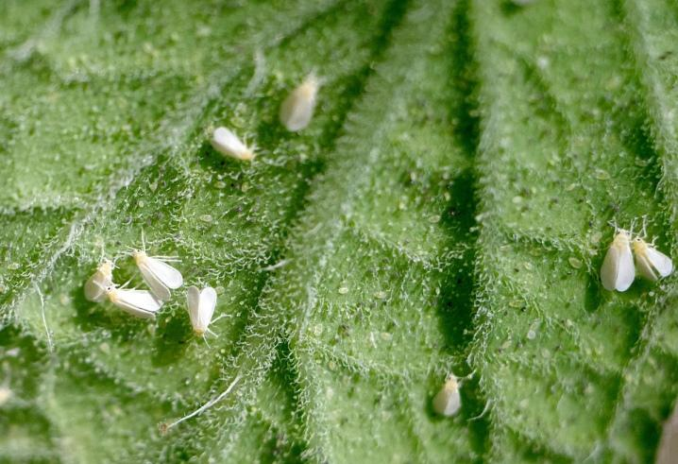
Whitefly
Tomato
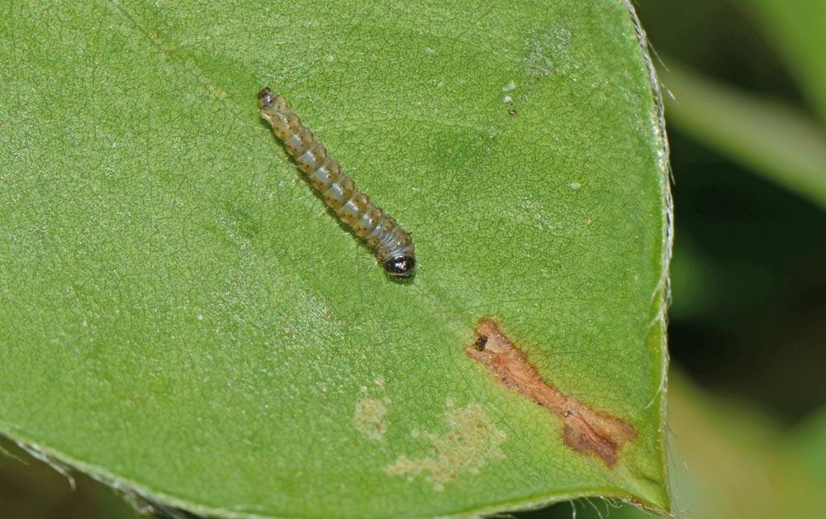
Leaf Miner
Groundnut
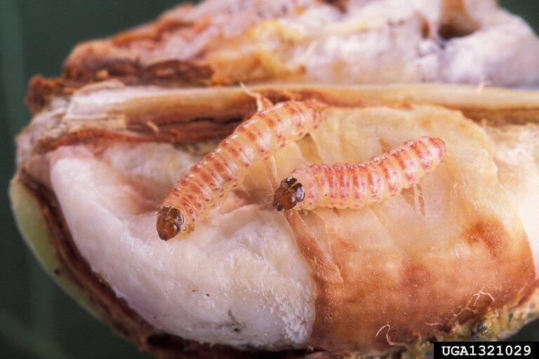
Pink Bollworm
Cotton
Total:
6 major pests
Step 5: Where do the images come from?
This is where your question becomes important.
Training Data
Use existing public datasets.
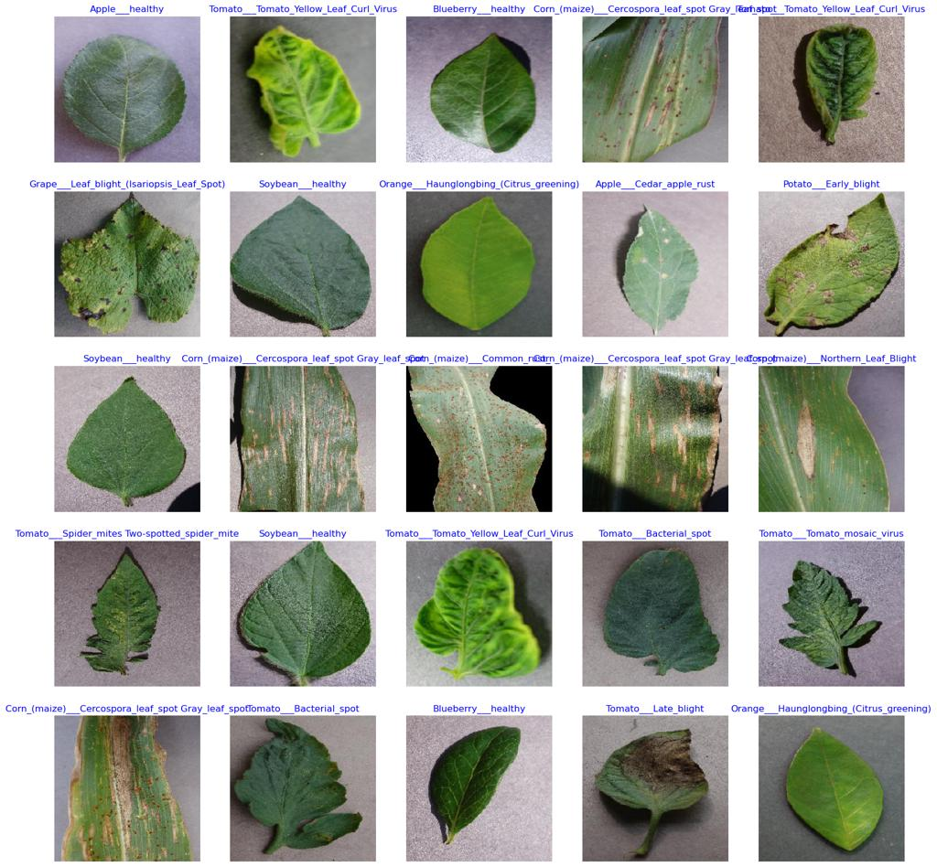
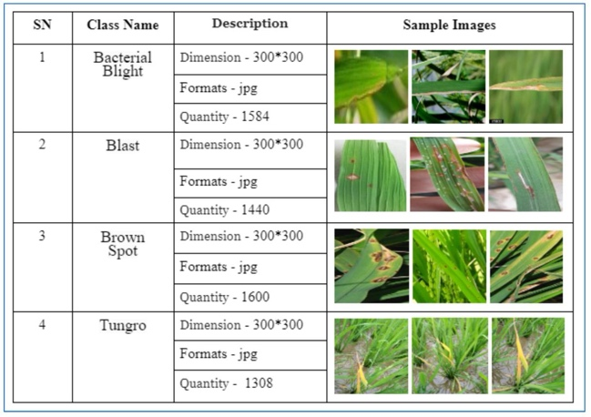
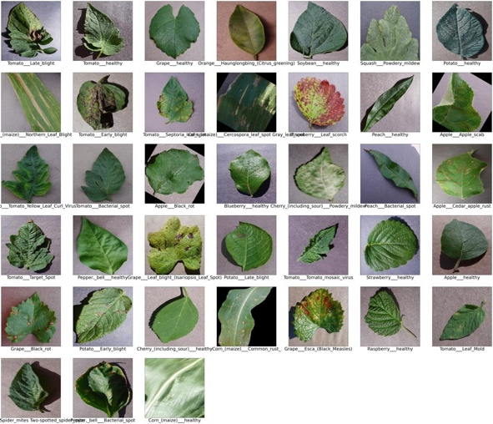
5
Examples:
- PlantVillage
- AIHub agricultural datasets
- Kaggle crop disease datasets
Train your model on these.
Demo Data
For the SIH demo,
you can use:
- Validation images from the dataset
- Your own field photographs (if available)
That's perfectly acceptable.
Step 6: What about GPS?
This is the part I'd do carefully.
Don't randomly change GPS values.
Instead,
create simulated farm records.
Example database:
|
Farm
|
Taluk
|
Crop
|
Latitude
|
Longitude
|
| --- | --- | --- | --- | --- |
|
Farm-001
|
Kancheepuram
|
Paddy
|
Actual coordinate
|
Actual coordinate
|
|
Farm-002
|
Krishnagiri
|
Tomato
|
Actual coordinate
|
Actual coordinate
|
|
Farm-003
|
Villupuram
|
Groundnut
|
Actual coordinate
|
Actual coordinate
|
Then,
when a demo image is uploaded,
it is assigned to that farm.
Now your heatmap becomes believable.
Example Demo Scenario
Imagine this sequence.
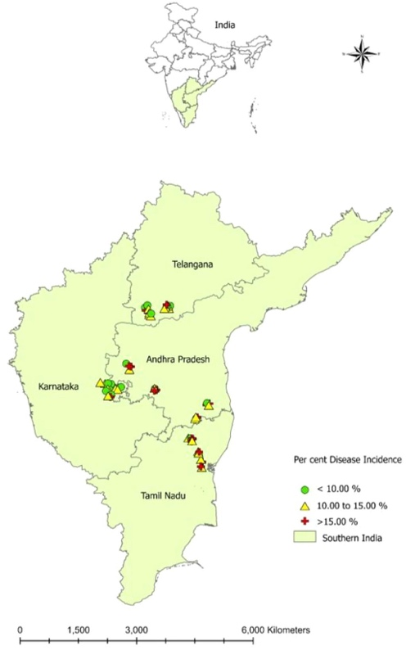
Day 1
Farm-001
- Kancheepuram
- Paddy
- Rice Blast detected.
Day 2
Farm-005
- Kancheepuram
- Rice Blast.
Day 3
Farm-011
- Nearby village
- Rice Blast.
Now,
Government Dashboard shows:
- Kancheepuram hotspot
- Risk increasing
- Extension visit recommended
This is exactly what the problem statement describes.
Step 7: Weather Integration
For each farm:
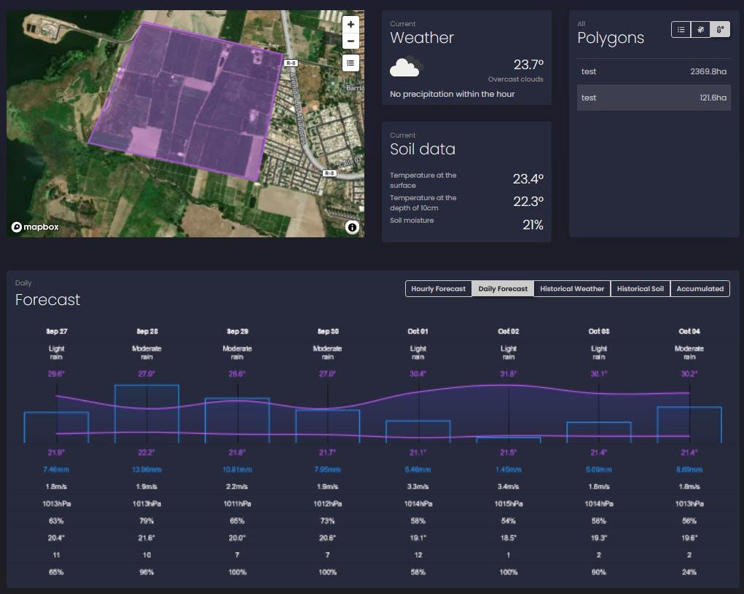
- GPS
- Weather API
- Temperature
- Humidity
- Rain forecast
Then your Risk Engine can say:
|
Disease
|
Risk
|
| --- | --- |
|
Rice Blast
|
82%
|
|
Brown Spot
|
31%
|
|
Stem Borer
|
18%
|
This feels much more intelligent than only showing image predictions.
Step 8: How the Entire Prototype Works
Here's the complete logical flow.
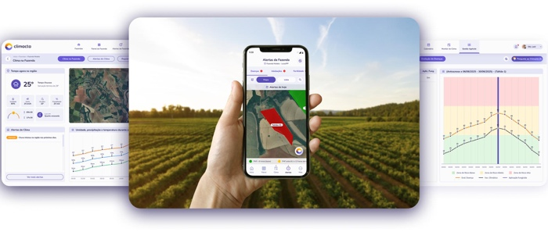
Farmer selects:
- Taluk
- Crop
- Farm
↓
Uploads leaf image.
↓
AI detects disease.
↓
Weather API fetches local conditions.
↓
Risk Engine predicts outbreak probability.
↓
GPS tags the case.
↓
Hotspot map updates.
↓
Extension officer validates.
↓
Farmer receives treatment advice.
↓
Follow-up image updates case status.
↓
Government dashboard tracks district-wide trends.
One suggestion that could genuinely impress SIH judges
Instead of hardcoding "Taluk → Crop," create a small Crop Intelligence Registry inside your database.
Example:
|
Taluk
|
Supported Crops
|
| --- | --- |
|
Kancheepuram
|
Paddy
|
|
Krishnagiri
|
Tomato
|
|
Villupuram
|
Groundnut
|
|
Thiruvallur
|
Paddy, Groundnut
|
Now the app behaves intelligently: when a farmer selects Krishnagiri, the app automatically prioritizes Tomato diseases and pests, loads the correct AI model, applies the relevant weather-risk rules, and shows only the appropriate IPM recommendations. It feels like the system understands the local agricultural context rather than being a generic disease detector, and that kind of contextual intelligence is exactly the sort of detail SIH judges tend to appreciate.

YES. This is actually where your solution can become much stronger than a typical SIH project. And your workflow is exactly right:
AI suggests → Extension Officer verifies → Final advisory reaches the farmer.
The important thing is: don't let the AI invent treatments. Make it behave like a government agricultural advisory assistant that recommends actions from trusted agricultural knowledge, and let the Extension Officer be the final authority.
This is also safer and more realistic.
The Recommendation Workflow
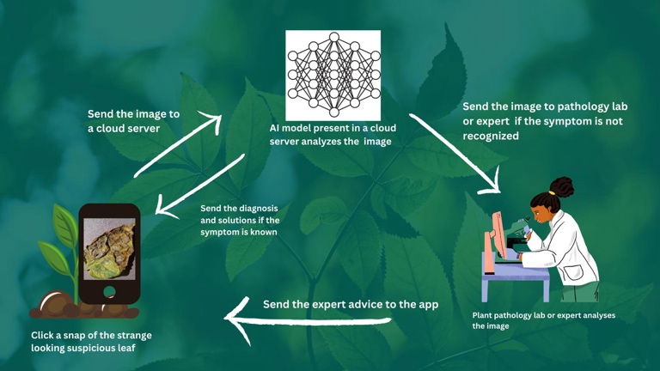
Instead of:
Disease → Pesticide
Build this workflow:
Disease Detection → Knowledge Base → AI Advisory → Extension Validation → Farmer
The AI retrieves recommendations from a Crop Health Knowledge Base, not from its own imagination.
Step 1: Build a Crop Health Knowledge Base
Think of it as a mini agricultural handbook inside your database.
For every disease, store:
|
Field
|
Example
|
| --- | --- |
|
Crop
|
Tomato
|
|
Disease
|
Early Blight
|
|
Symptoms
|
Brown concentric spots
|
|
Severity
|
Mild/Moderate/Severe
|
|
Preventive Action
|
Remove infected leaves
|
|
Cultural Practice
|
Improve air circulation
|
|
Safe Chemical Option
|
Approved fungicide (generic name)
|
|
Organic Option
|
Neem-based treatment
|
|
Precautions
|
Wear PPE
|
|
Lab Referral Needed?
|
Yes/No
|
This becomes your recommendation engine.
Step 2: Use Government Agricultural Sources
For SIH, this is a huge credibility point.
Instead of making your own remedies, compile them from official sources.
Use sources like:
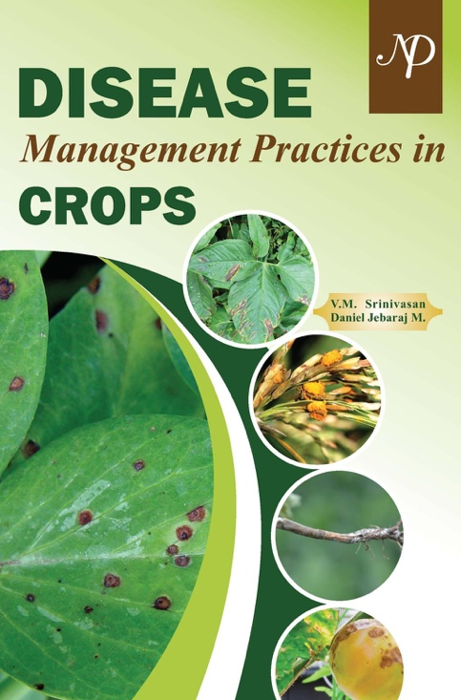
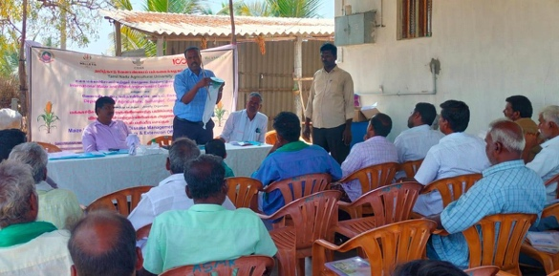
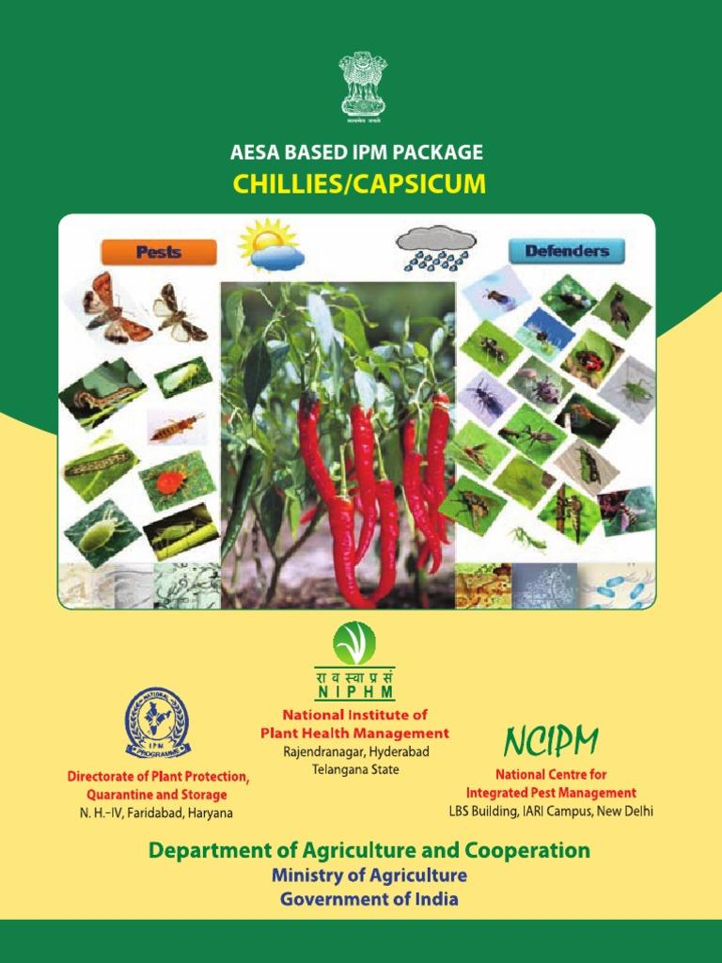
4
- ICAR
- Tamil Nadu Agricultural University (TNAU)
- National Centre for Integrated Pest Management (NCIPM)
- Directorate of Plant Protection, Quarantine & Storage
These organizations already publish:
- Disease management guides
- IPM practices
- Safe pesticide recommendations
- Approved dosage guidelines
Your app simply digitizes this knowledge.
Step 3: Follow IPM (Integrated Pest Management)
Notice something important.
The SIH problem statement specifically says:
"Recommend Integrated Pest and Disease Management actions."
That means your recommendation should never jump straight to chemicals.
Every advisory should follow a hierarchy.
IPM Recommendation Structure
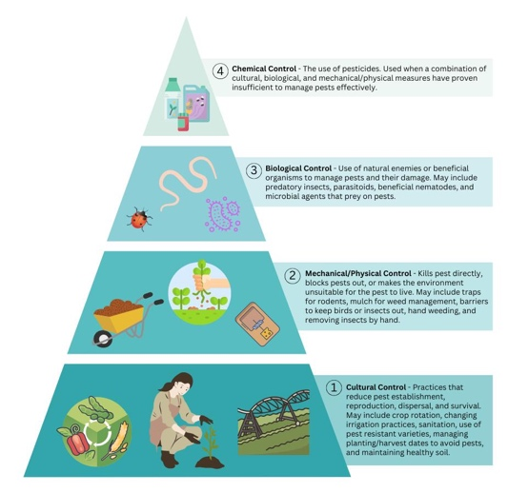
Level 1 — Prevention
Example:
- Remove infected leaves.
- Avoid overhead irrigation.
- Improve field sanitation.
Level 2 — Cultural Practices
Example:
- Increase spacing.
- Rotate crops.
- Remove weeds.
Level 3 — Biological Options
Example:
- Neem-based products.
- Beneficial microbes.
- Traps.
Level 4 — Chemical Option
Only when necessary.
Instead of saying:
"Use Brand X."
Say:
"Use a fungicide containing Mancozeb (follow local agricultural guidelines)."
Using generic active ingredients is much safer and aligns better with government advisories.
Step 4: Example Recommendation Cards
This is exactly how I'd design the UI.
Example 1 — Tomato Early Blight
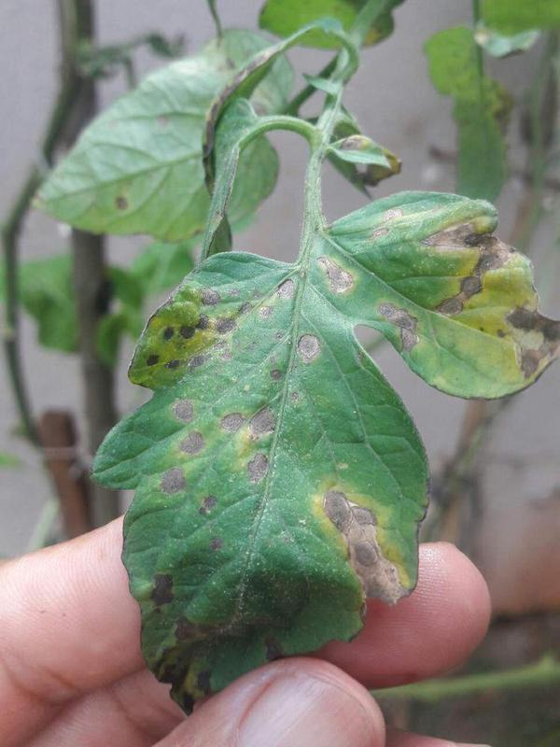
AI Detection
- Disease: Early Blight
- Confidence: 94%
- Severity: Moderate
Recommended Actions
|
Type
|
Recommendation
|
| --- | --- |
|
Immediate
|
Remove infected leaves
|
|
Cultural
|
Avoid wet foliage
|
|
Biological
|
Neem-based treatment
|
|
Chemical
|
Mancozeb-based fungicide (as per local guidelines)
|
|
Safety
|
Wear gloves and avoid spraying during high winds
|
Status
Pending Extension Validation
Example 2 — Rice Blast
AI Detection
- Disease: Rice Blast
- Risk: High
Recommended Actions
- Reduce excessive nitrogen application.
- Improve drainage.
- Monitor nearby fields.
- Consider approved fungicide if symptoms increase.
Again,
notice that chemicals are not the first recommendation.
Step 5: Extension Officer Dashboard
This is where your workflow becomes powerful.
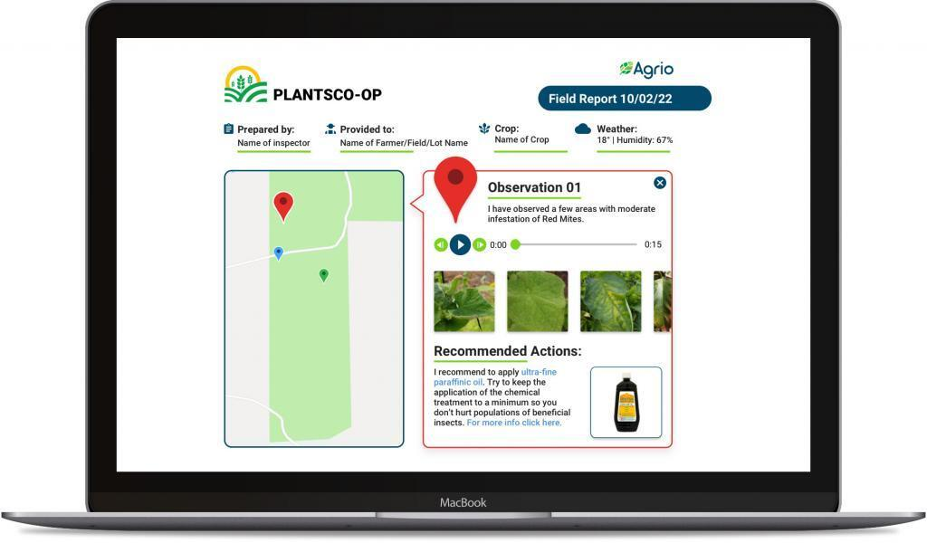
When a case appears, the officer sees:
|
Item
|
Example
|
| --- | --- |
|
Farmer
|
Ramesh
|
|
Taluk
|
Kancheepuram
|
|
Crop
|
Paddy
|
|
AI Disease
|
Rice Blast
|
|
Confidence
|
91%
|
|
Risk
|
High
|
The officer has four buttons.
Approve
Modify Advice
Request Lab Sample
Schedule Farm Visit
This is almost exactly what government extension workflows look like.
Step 6: Laboratory Referral Logic
Not every case should go to the lab.
Your system can use simple rules.
|
AI Confidence
|
Action
|
| --- | --- |
|
Above 90%
|
Auto-send advisory
|
|
70–90%
|
Extension review
|
|
Below 70%
|
Recommend lab sample
|
Also trigger lab referral if:
- unusual symptoms,
- multiple diseases overlap,
- outbreak spreads rapidly.
This makes the workflow feel intelligent.
Step 7: Follow-up Monitoring
After treatment,
the farmer receives reminders.
Example timeline:
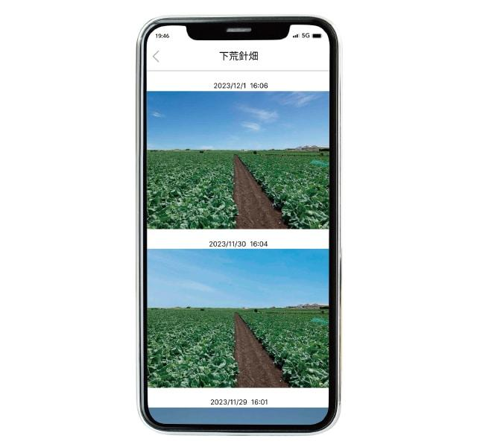
|
Day
|
Action
|
| --- | --- |
|
Day 0
|
Detection
|
|
Day 3
|
Upload new photo
|
|
Day 7
|
Compare severity
|
|
Day 14
|
Case closed
|
The AI can even compare before/after images.
Step 8: Database Design for Recommendations
I'd create one dedicated table.
CropHealthKnowledgeBase
|
Column
|
Purpose
|
| --- | --- |
|
Crop
|
Tomato
|
|
Disease
|
Early Blight
|
|
Severity
|
Moderate
|
|
Preventive
|
Remove infected leaves
|
|
Cultural
|
Improve airflow
|
|
Biological
|
Neem
|
|
Chemical
|
Generic active ingredient
|
|
Safety
|
PPE instructions
|
|
Lab Referral
|
Boolean
|
|
Source
|
ICAR/TNAU
|
Then another table.
CaseReview
|
Column
|
Purpose
|
| --- | --- |
|
AI Prediction
|
Stored
|
|
Officer Decision
|
Approve/Modify
|
|
Lab Required
|
Yes/No
|
|
Visit Scheduled
|
Date
|
|
Final Advisory
|
Sent to farmer
|
This separation is very clean.
One feature I think could become your SIH "wow factor"
Instead of showing farmers a long paragraph, create an "Advisory Confidence Card."
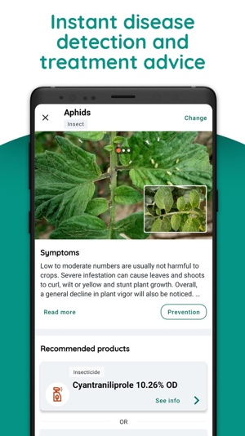
Example:
Disease: Early Blight (94% Confidence)
Risk Level: High
Today's Actions:
- Remove infected leaves.
- Avoid overhead watering.
- Monitor nearby plants.
Status: Awaiting Extension Officer Confirmation.
This is powerful because it combines AI confidence, practical next steps, and government oversight in one screen. It also reinforces that the app is assisting, while the extension officer remains the final authority—exactly matching the wording of SIH PS 26131.
YES! This is actually where your workflow becomes much closer to how a real government agricultural extension system works. The Extension Officer shouldn't just "approve" the AI prediction—the confirmation should unlock the next workflow. Think of the officer as converting an AI suspicion into an official case.
So the flow becomes:
AI Detects → Officer Confirms → Action Plan Begins → Monitoring Continues → Case Closes
This makes your system feel like a real field management platform rather than just a disease detection app.
Complete Workflow After Extension Officer Confirmation
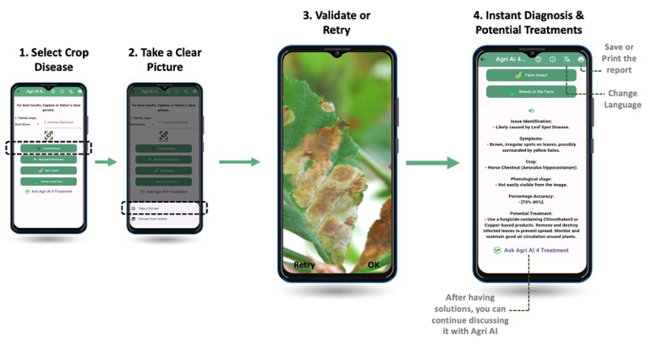
Scenario 1: Officer Confirms the AI Diagnosis (Most Common)
Example:
- Crop: Tomato
- Disease: Early Blight
- AI Confidence: 94%
The officer clicks "Approve."
What happens automatically?
The system creates an Official Crop Health Case and sends the farmer a structured action plan.
Farmer's Action Plan
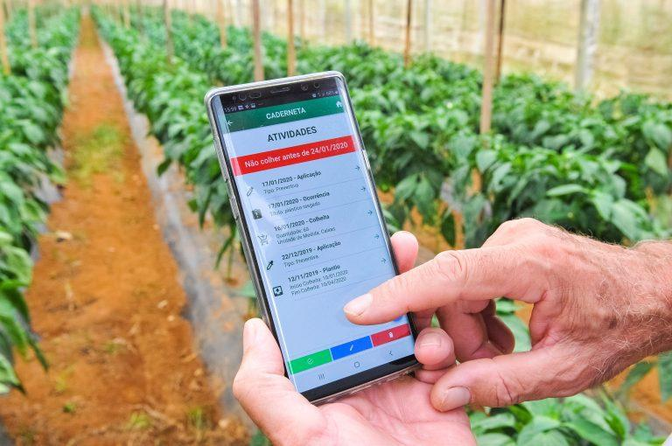
Today's Actions
- Remove infected leaves.
- Avoid overhead irrigation.
- Inspect nearby plants.
Within 24 Hours
- Apply recommended IPM practice.
- Use approved treatment (if required).
After 3 Days
- Upload a new photo.
The app now becomes a task manager.
Scenario 2: Officer Modifies the Recommendation
Suppose the AI says:
Early Blight
But the officer notices it is actually:
Septoria Leaf Spot.
Instead of rejecting everything,
they edit the recommendation.
The farmer receives:
Updated by Extension Officer
This builds trust.
Scenario 3: Officer Requests a Laboratory Sample
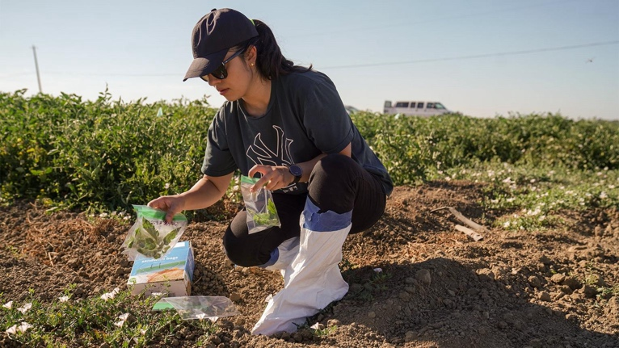
Some cases are uncertain.
The officer selects:
Request Sample
The farmer immediately receives instructions.
Example:
- Collect 3 affected leaves.
- Place them in a clean paper bag.
- Submit at the nearest agricultural office.
The case status changes to:
Awaiting Laboratory Confirmation
Once the lab confirms,
the recommendation is updated.
Scenario 4: Officer Schedules a Farm Visit
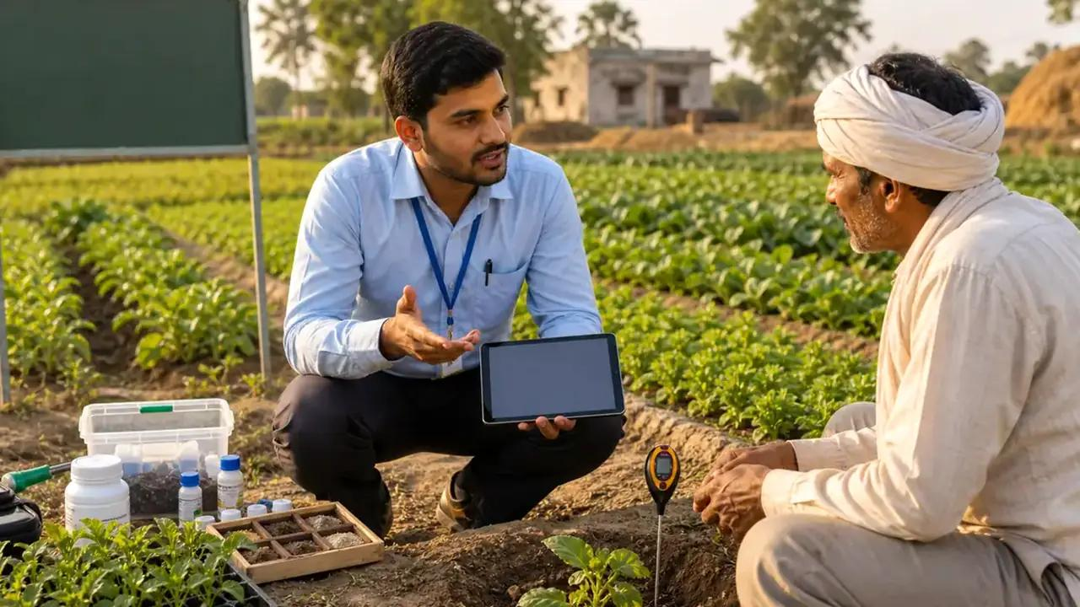
This happens when:
- outbreak is severe,
- multiple farms are affected,
- confidence is low.
The app shows:
Farm Visit Scheduled
Date:
27 August
Time:
10:30 AM
The farmer receives a notification.
Follow-Up Monitoring (The Important Part)
This is the feature many SIH teams will probably miss.
After confirmation,
the system doesn't stop.
It keeps monitoring.
Recovery Timeline
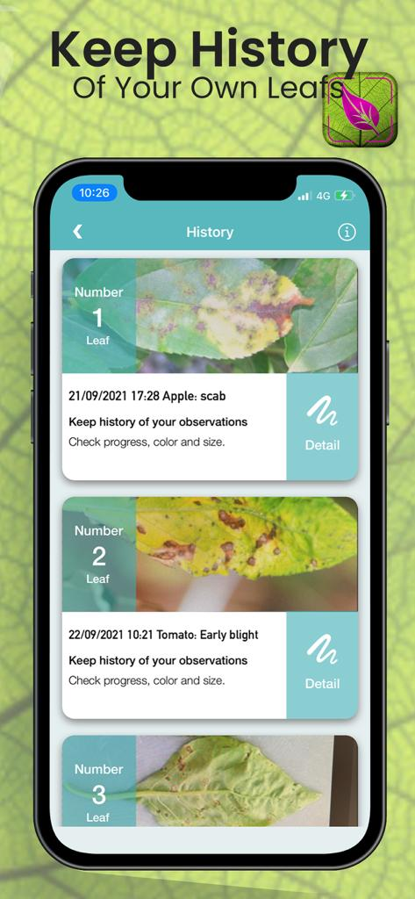
|
Day
|
System Action
|
| --- | --- |
|
Day 0
|
Case confirmed
|
|
Day 3
|
Reminder to upload new photo
|
|
Day 7
|
Compare severity
|
|
Day 14
|
Recovery assessment
|
|
Day 21
|
Case closed (if healthy)
|
This makes the solution much more practical.
Before-and-After AI Comparison
Instead of running only disease detection,
the AI now performs:
Progress Assessment
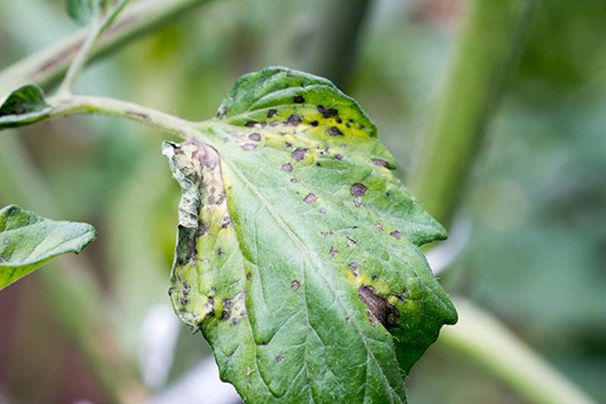
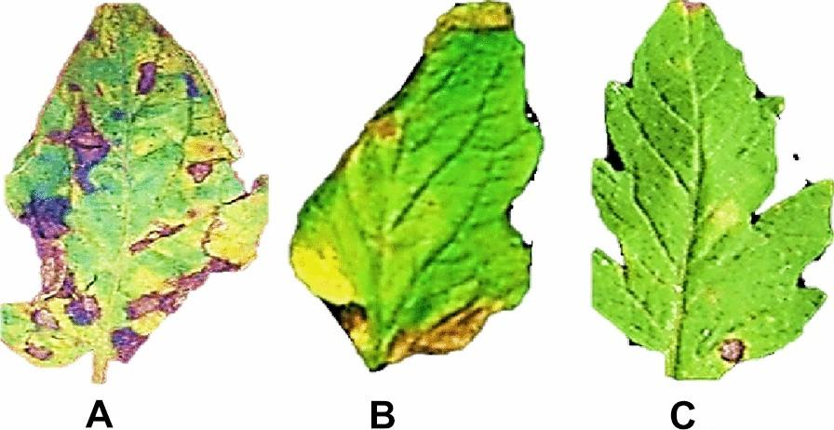
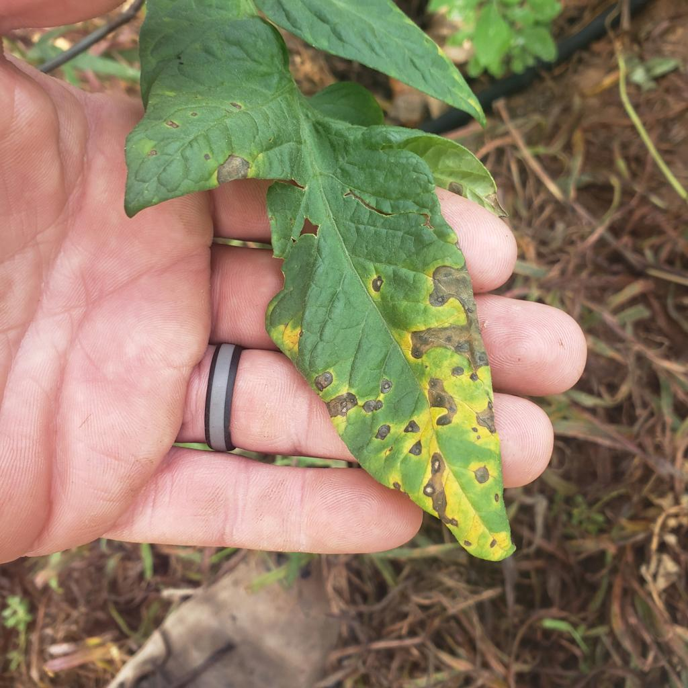
Example:
|
Before
|
After
|
| --- | --- |
|
35 lesions
|
12 lesions
|
|
High severity
|
Mild severity
|
|
Risk High
|
Risk Low
|
The farmer sees improvement visually.
Government Dashboard Updates Too
Every confirmed case updates district surveillance.
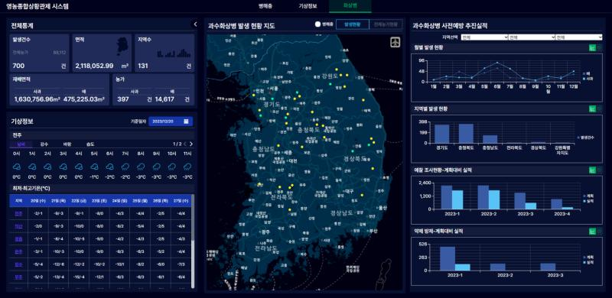
Instead of only showing:
- Disease Count
it now tracks:
- Confirmed Cases
- Cases Under Treatment
- Laboratory Cases
- Farm Visits Scheduled
- Recovered Farms
- Active Hotspots
This gives officials meaningful operational data.
Case Status Lifecycle
This is probably the cleanest way to design your database and UI.
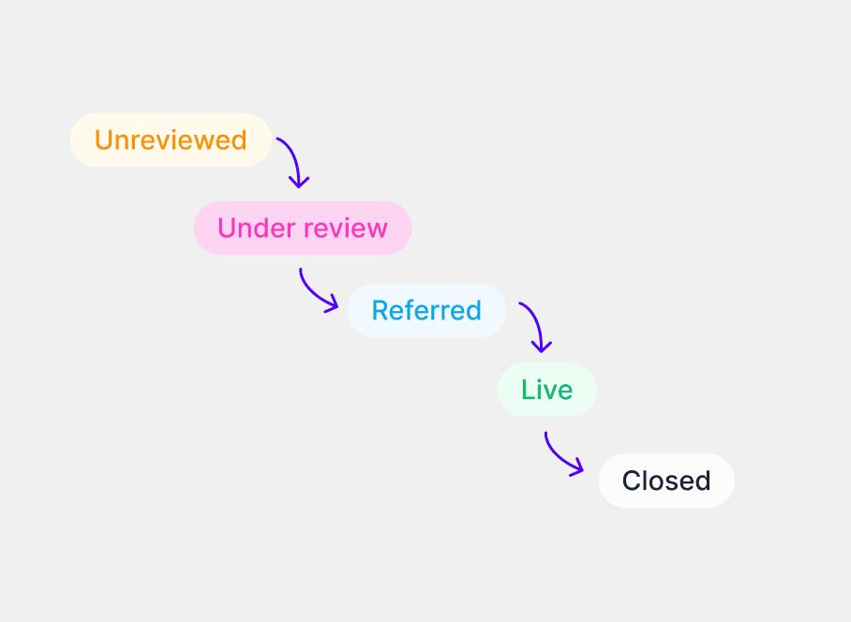
|
Status
|
Meaning
|
| --- | --- |
|
AI Detected
|
Initial prediction
|
|
Pending Review
|
Waiting for officer
|
|
Confirmed
|
Official diagnosis
|
|
Under Treatment
|
Farmer following advisory
|
|
Lab Verification
|
Sample requested
|
|
Visit Scheduled
|
Officer will inspect
|
|
Recovering
|
Follow-up shows improvement
|
|
Closed
|
Case resolved
|
One feature I'd definitely add (this could become your SIH differentiator)
Instead of sending the farmer a one-time advisory, introduce a "Treatment Journey."
Imagine the farmer sees this in the app:
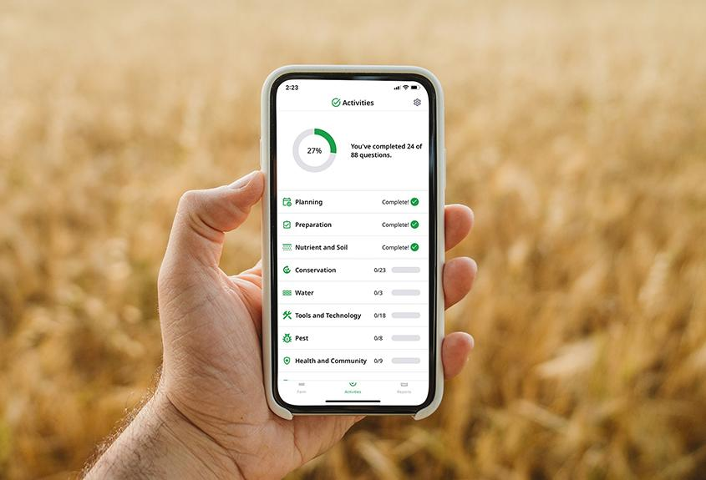
- ✅ Disease Confirmed
- ✅ Initial Advisory Sent
- ⏳ Follow-up Photo Due Tomorrow
- ⏳ Recovery Check in 3 Days
- 🔒 Case Closure Pending
It turns the recommendation into a guided workflow, which aligns perfectly with the problem statement's phrase "follow-up monitoring" and makes your solution feel like a complete agricultural case management system rather than just an AI classifier.

